**Analysis Reports based on various Factors with visualization Chart:**

1. Sales Per Branch:

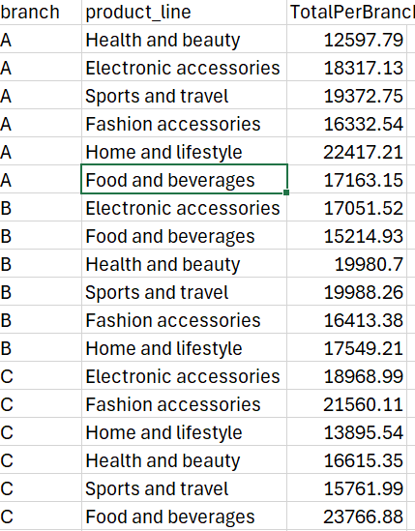

Visualization Charts:

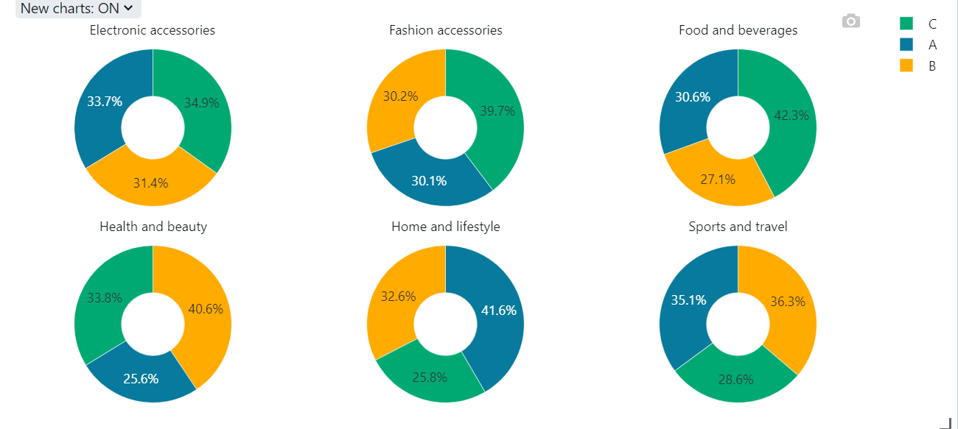

2.Average Rate Per Product

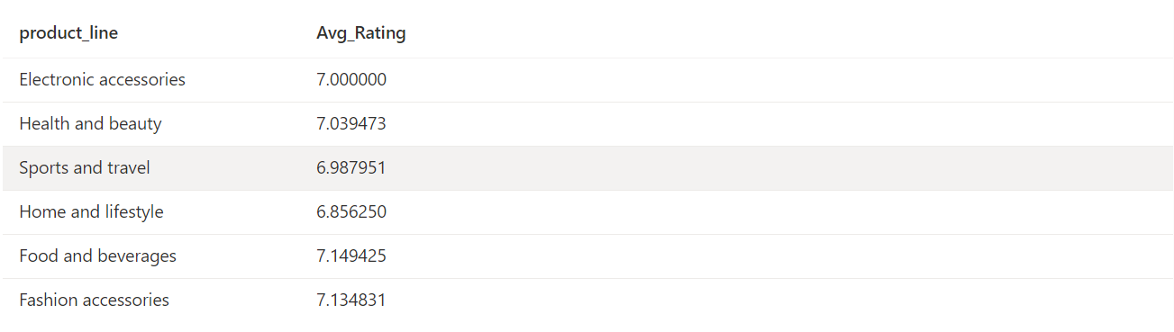

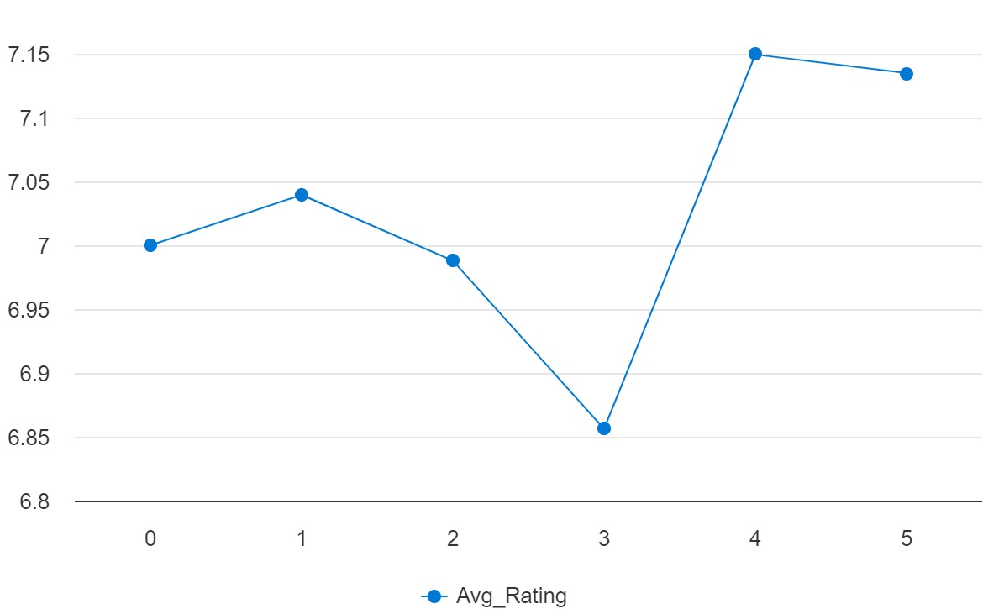

3. Average unit price and quantity per product line

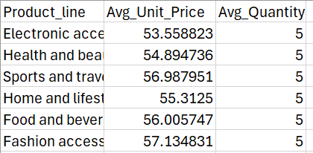

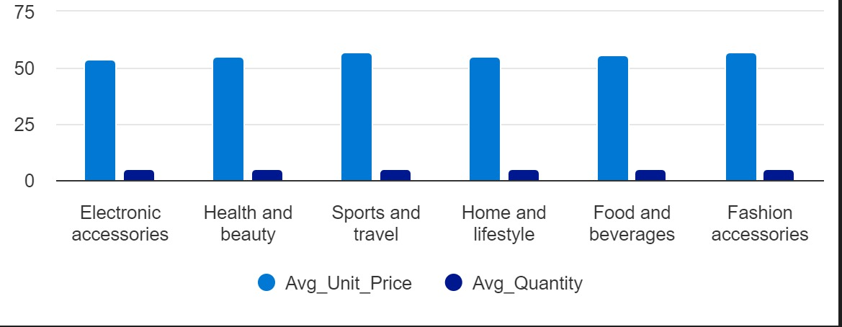

4. Average spending per customer type

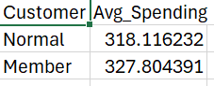

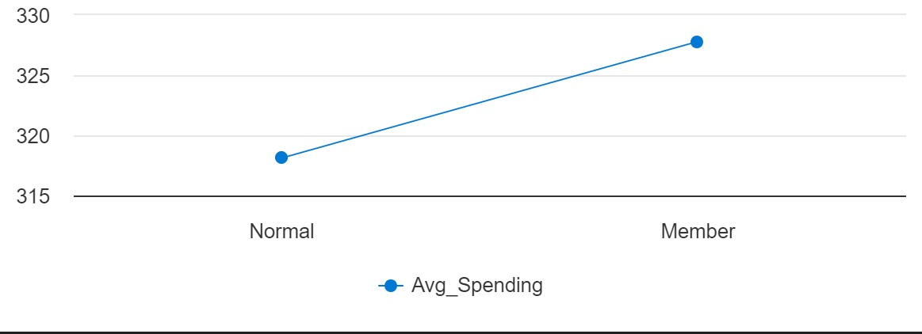

5. Distribution of customer type and gender across product lines

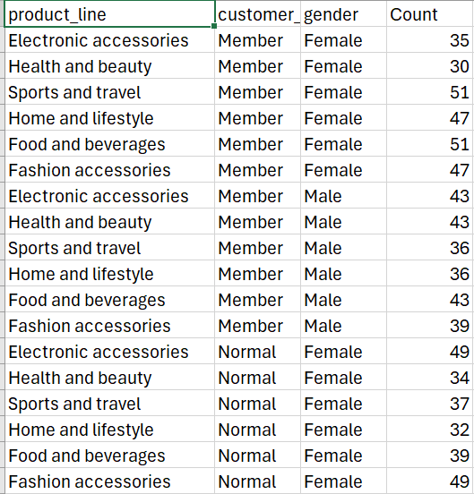

5.Total Sale Per Branch

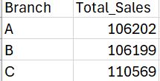

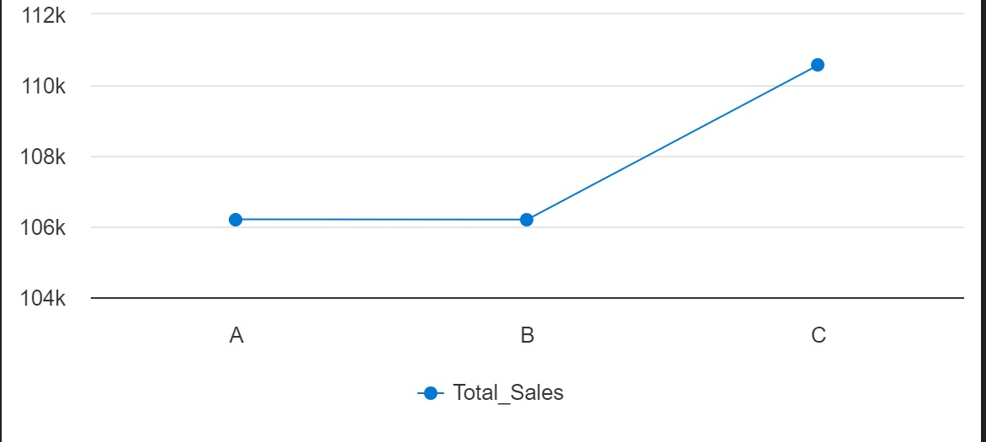

6. Total Sale Per City:

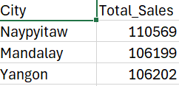

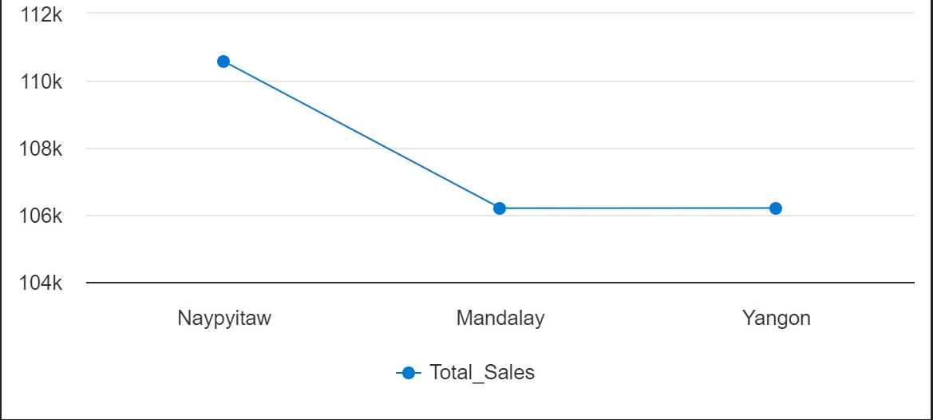

|  |  |  |
| --- | --- | --- |
|  |  |  |

7.Monthly Sale:

Visualization Chart:

8.Daily Sales:

|  |  |
| --- | --- |
| Sales Date | TotalPerDay |
| 01/01/2019 | 4745.19 |
| 02/01/2019 | 1945.5 |
| 03/01/2019 | 2078.12 |
| 04/01/2019 | 1623.68 |
| 05/01/2019 | 3536.69 |
| 06/01/2019 | 3614.22 |
| 07/01/2019 | 2834.24 |
| 08/01/2019 | 5293.78 |
| 09/01/2019 | 3021.36 |
| 10/01/2019 | 3560.95 |
| 11/01/2019 | 2114.97 |
| 12/01/2019 | 5184.75 |
| 13/01/2019 | 2451.21 |
| 14/01/2019 | 3966.62 |
| 15/01/2019 | 5944.29 |
| 16/01/2019 | 4289.09 |
| 17/01/2019 | 3142.78 |
| 18/01/2019 | 2780.47 |
| 19/01/2019 | 4914.73 |
| 20/01/2019 | 3655.45 |
| 21/01/2019 | 2392.12 |
| 22/01/2019 | 1704.78 |
| 23/01/2019 | 5994.2 |
| 24/01/2019 | 5402.05 |
| 25/01/2019 | 4700.39 |
| 26/01/2019 | 4457.52 |
| 27/01/2019 | 4635.89 |
| 28/01/2019 | 4999.72 |
| 29/01/2019 | 3516.57 |
| 30/01/2019 | 2558.27 |
| 31/01/2019 | 5232.51 |
| 01/02/2019 | 2444.54 |
| 02/02/2019 | 4140.97 |
| 03/02/2019 | 5467.95 |
| 04/02/2019 | 2439.51 |
| 05/02/2019 | 3031.13 |
| 06/02/2019 | 2905.43 |
| 07/02/2019 | 7228.22 |
| 08/02/2019 | 5084.67 |
| 09/02/2019 | 3271.9 |
| 10/02/2019 | 3141.03 |
| 11/02/2019 | 4542.15 |
| 12/02/2019 | 2998.99 |
| 13/02/2019 | 934.25 |
| 14/02/2019 | 2454.1 |
| 15/02/2019 | 6830.79 |
| 16/02/2019 | 2503.78 |
| 17/02/2019 | 5299.59 |
| 18/02/2019 | 1496.03 |
| 19/02/2019 | 4228.13 |
| 20/02/2019 | 2706.42 |
| 21/02/2019 | 1393.75 |
| 22/02/2019 | 2442.32 |
| 23/02/2019 | 2339.58 |
| 24/02/2019 | 2722.47 |
| 25/02/2019 | 4807.23 |
| 26/02/2019 | 2408.16 |
| 27/02/2019 | 5859.46 |
| 28/02/2019 | 2097.03 |
| 01/03/2019 | 2634.37 |
| 02/03/2019 | 6560.31 |
| 03/03/2019 | 4853.19 |
| 04/03/2019 | 3894.46 |
| 05/03/2019 | 6230.9 |
| 06/03/2019 | 3092.61 |
| 07/03/2019 | 1438.26 |
| 08/03/2019 | 3125.41 |
| 09/03/2019 | 7474.05 |
| 10/03/2019 | 3163.25 |
| 11/03/2019 | 2961.25 |
| 12/03/2019 | 3677.54 |
| 13/03/2019 | 2063.63 |
| 14/03/2019 | 7214.63 |
| 15/03/2019 | 2942.42 |
| 16/03/2019 | 3154.48 |
| 17/03/2019 | 1976.29 |
| 18/03/2019 | 1292.85 |
| 19/03/2019 | 5740.41 |
| 20/03/2019 | 5458.21 |
| 21/03/2019 | 1877.52 |
| 22/03/2019 | 3179.15 |
| 23/03/2019 | 4095.04 |
| 24/03/2019 | 3477.48 |
| 25/03/2019 | 2272.97 |
| 26/03/2019 | 1962.52 |
| 27/03/2019 | 2902.81 |
| 28/03/2019 | 2229.42 |
| 29/03/2019 | 4023.25 |
| 30/03/2019 | 4487.06 |

**Improve the Business**

By setting up the pipeline we can

1. **Automate Data Processing**: Streamline the process of cleaning and transforming raw data, saving time and reducing manual errors.
2. **Derive Insights**: Analyze the transformed data to uncover trends, patterns, and insights that can inform business decisions.
3. **Improve Data Quality**: Ensure that the data used for analysis is clean and consistent, leading to more accurate insights.
4. **Scalability**: Easily scale your data processing capabilities as your data volume grows